INDIAN INSTITUTE OF TECHNOLOGY PALAKKAD



ID1110: INTRODUCTION TO PROGRAMMING

PROJECT REPORT

INSTRUCTOR: Dr ANISH HIRWE

TEAM MEMBERS:

142301030 PARVATHY RAJESH

122301005 ARYA S WARRIER

112301004 BANOTH RAJESH

**INTRODUCTION**

BACKGROUND AND CONTEXT

A to-do list app is a digital tool designed to help users organize and manage their tasks and priorities. With the increasing reliance on technology for daily tasks, such apps have become essential for individuals and businesses alike. They provide a convenient way to keep track of tasks, set reminders, and ensure nothing falls through the cracks.

PROBLEM STATEMENT AND OBJECTIVES

The problem statement could focus on the challenges people face in managing their tasks effectively without a centralized system. Common issues include forgetting important tasks, struggling to prioritize, and feeling overwhelmed by the volume of work. The objective of your project would be to address these challenges by creating a user-friendly and efficient to-do list app.

SIGNIFICANCE AND MOTIVATION

The significance of developing a to-do list app lies in its potential to improve productivity and reduce stress for users. By providing a streamlined way to organize tasks, set deadlines, and track progress, the app can help individuals and teams achieve their goals more effectively. The motivation behind the project could stem from a desire to make a positive impact on people's lives by simplifying task management and promoting better time management habits. Additionally, the project could serve as a learning experience for you, allowing you to gain valuable skills in app development, user interface design, and project management.

**PROJECT OVERVIEW**

PROJECT GOALS AND SCOPES

The primary goal of your to-do list app project is to develop a functional and user-friendly application that helps individuals and teams manage their tasks efficiently. The app should allow users to create, prioritize, categorize, and track tasks easily. Additional features could include reminders, due dates, subtasks, collaboration options, and synchronization across devices.

The scope of the project should outline the specific functionalities and features you plan to include in the initial version of the app. It's essential to prioritize essential features to ensure a manageable scope for development within the project timeline.

PROJECT TIMELINE

|  |  |
| --- | --- |
| TASKS | TIMELINE |
| MEETING 1:  TOPIC SELECTION | MARCH 15 |
| MEETING 2:  TASK DISTRIBUTION | MARCH 25 |
| MEETING 3:  INITIATION OF PROJECT | APRIL 2 |
| MEETING 4:  PROGRESS ASSESSMENT | APRIL 15 |
| MEETING 5:  TESTING AND QUALITY ASSURANCE | APRIL 21 |
| MEETING 6:  REPORT AND CORRECTION | APRIL 28 |

PROJECT REPOSITORY:

Link: [<https://drive.google.com/drive/u/1/folders/1R88OQn42-K26rsr6jB-IZu-2hqRL9MqV>]

Github Repository link:[ <https://github.com/142301030/to_do> ]

TEAM MEMBERS AND CONTRIBUTION:

142301030 PARVATHY RAJESH🡪 REPORT AND CODE

122301005 ARYA S WARRIER🡪 TOPIC SELECTION AND CODE

112301004 BANOTH RAJESH🡪REPORT AND CODE

**METHODOLOGY**

APPROACH AND METHODOLOGY EMPLOYED

1.Requirement Gathering Understand what features users expect from a to-do list app. This could include add tasks, delete tasks, marking completed tasks, etc.

2.Searching for suitable platform and technologies to make the app.

3.Preparing the python code required for app development.

4.Running the code and testing whether the app is functioning as per the requirements.

6.Debugging and fixing the errors found.

7.Final assessment of the app by running it again and then preparing the report

TOOLS, TECHNOLOGIES AND FRAMEWORKS USED

1.Kivy MD

2.Python codes

3.Pycharm (JetBrains)

**RESULTS AND ANALYSIS**

ACHIEVED RESULTS AND FINDINGS

Results:

1.Developed a user-friendly interface for the to do list app.

2.Implemented tasks like task creation, deletion and editing functionalities.

3.Conducted sample testing to get feedback and find defects.

Key Findings:

1.Simple and easy to use

2.Could have added more features for performance optimization for smoother operation especially on low-end devices.

**DATA ANALYSIS AND INTERPRETATION:**

TASK COMPLETION RATE:

On analysing the completion of tasks given by users, it was found that various tasks like addition of task, deletion of task and marking as completed in a reasonably short span of time of order of few seconds. Noticeable lag was not found.

TASK CATEGORIES:

The App we create has the ability to add and delete task for a particular date selected. It can also mark the tasks as completed once it is completed.

FEEDBACK ANALYSIS:

It was found to serve the function it is meant for perfectly. It is simple to use. But it can be further modified with some more features to make it more efficient.

**VISUALIZATION OF FINDINGS**:

1. On running the code, a separate window for to-do app opens up. We can see the name of the app along with a ‘+’ sign which is used to add tasks.

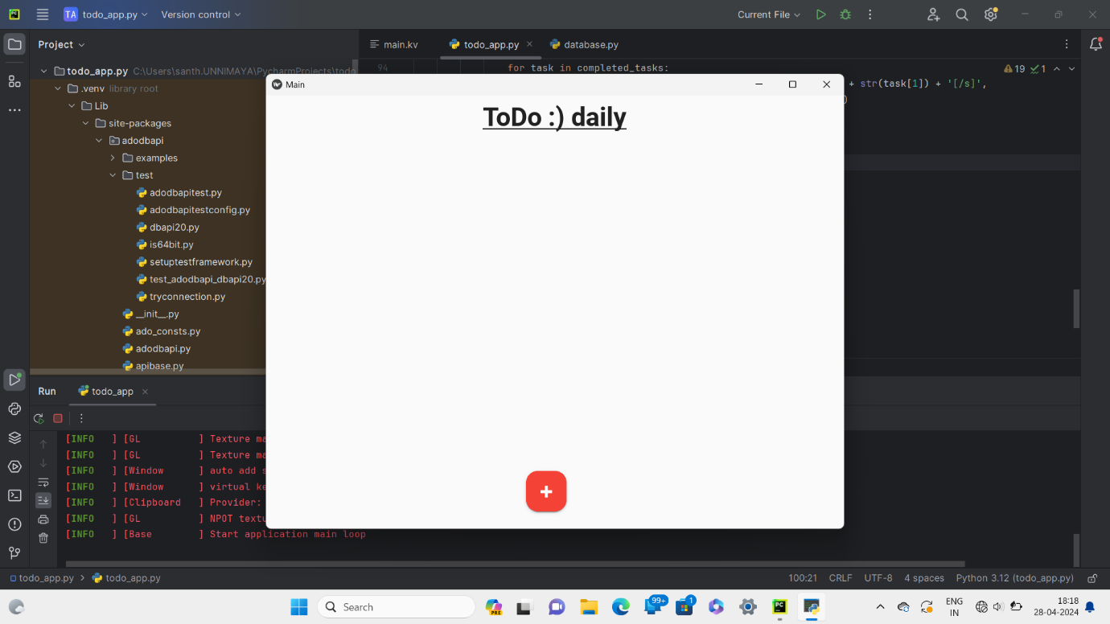2.On clicking the ‘+’ sign a dialogue box appears where you can select the date and name the task.

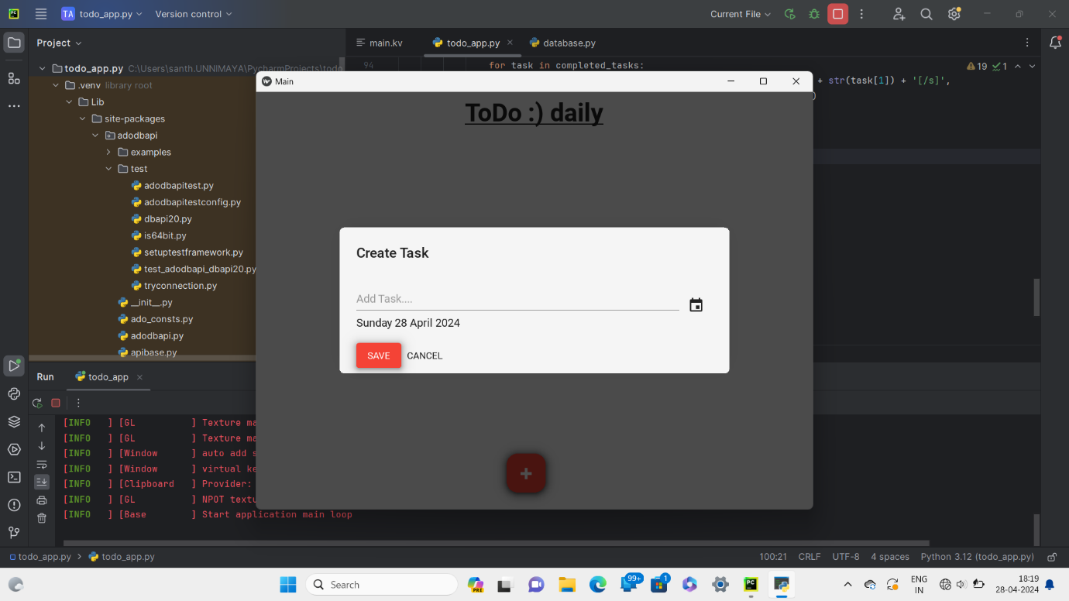

3. A calendar opens up on pressing the calendar option.

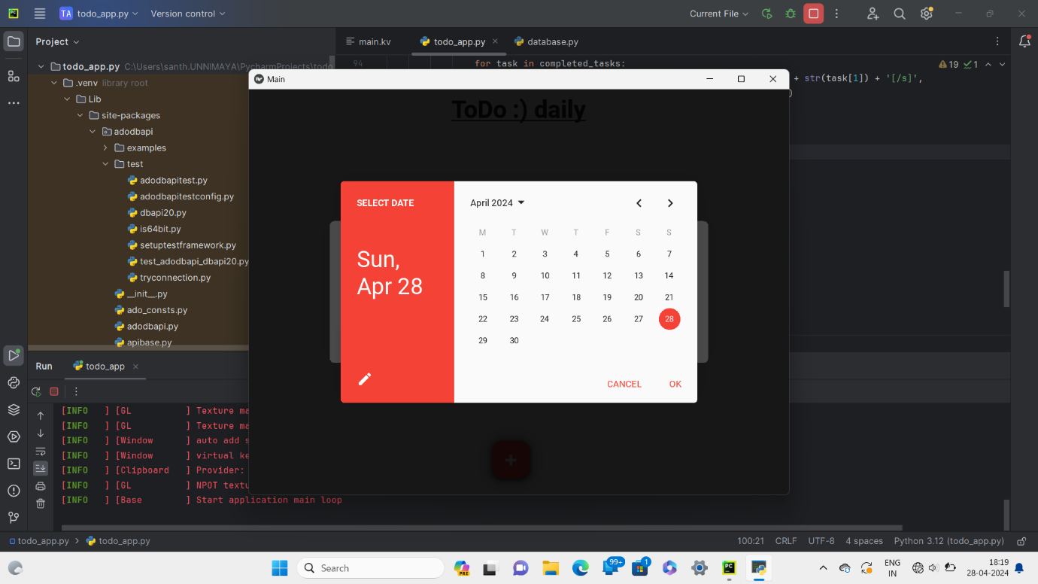

4. The new task is added with the date.

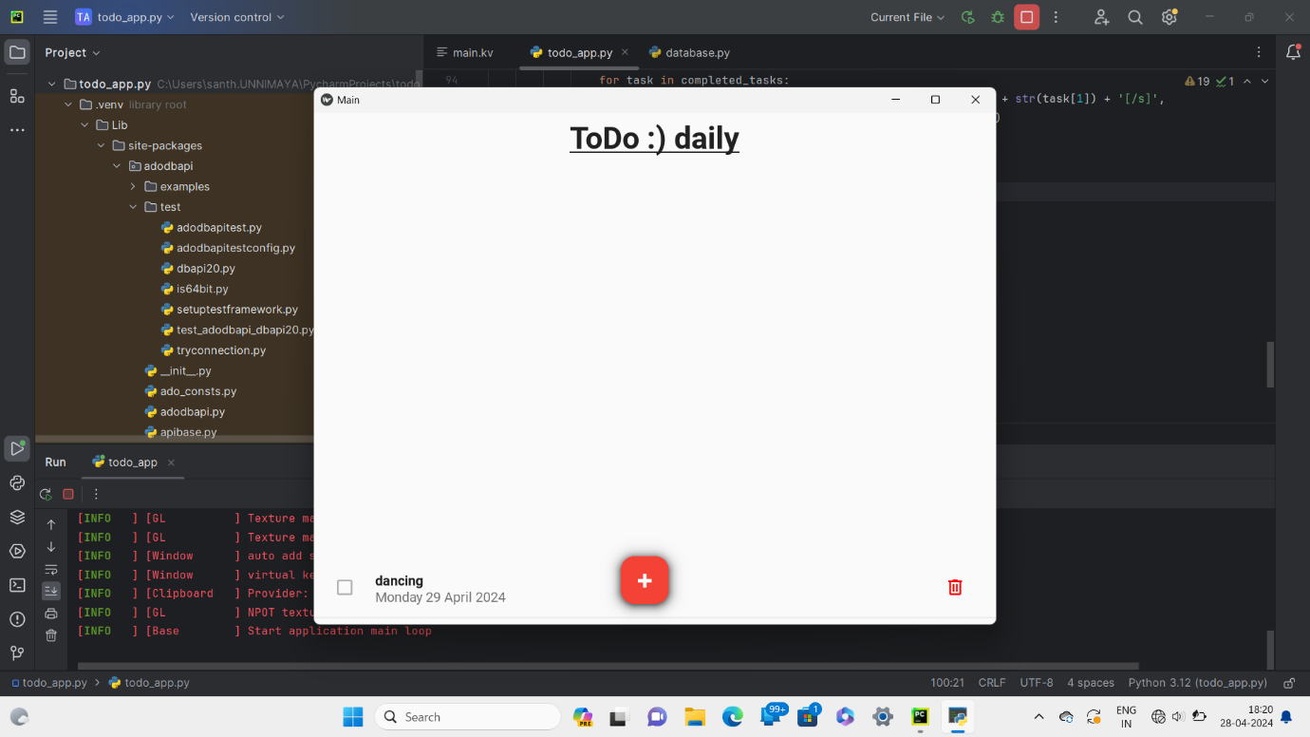

5. We can add more than one task and also mark the task which has got completed.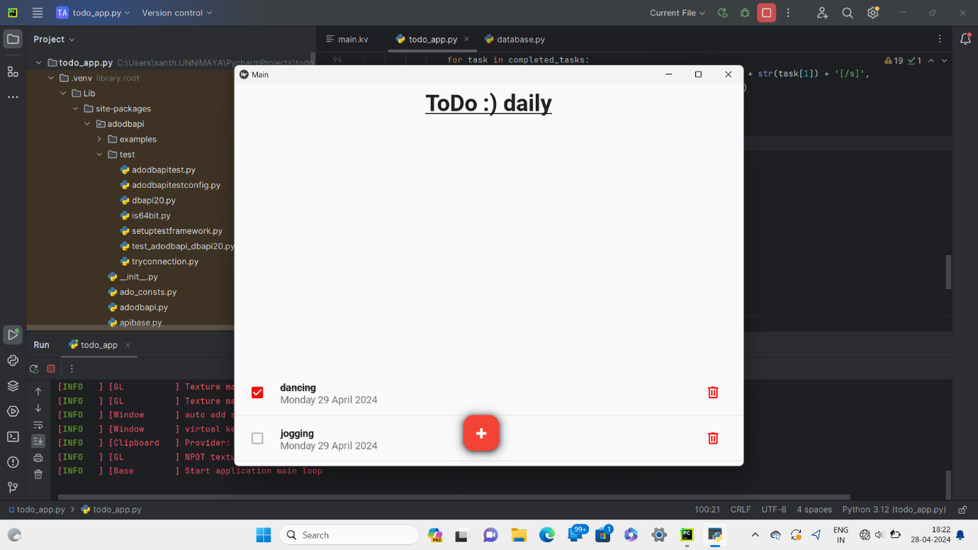

**DISCUSSION OF CHALLENGES AND SOLUTIONS**:

CHALLENGES:

1. Features like adding reminders, getting notification is not available yet.
2. It could have been more efficient.

SOLUTIONS:

1. Extending the code to add the above features.

**CONCLUSION AND FUTURE WORK**

SUMMARY OF OUTCOMES AND CONTRIBUTIONS:

1. Improved Productivity: Users can organize tasks, set priorities, and track progress, leading to increased productivity and efficiency in completing tasks.
2. Customization: Users can personalize their to-do lists with categories, tags, labels, and customizations to suit their preferences and workflow.

ASSESSMENT OF PROJECT SUCCESS

Within our limited knowledge of Python programming language, we were able to create a simple but useful to-do-list app.

**LESSONS LEARNED AND RECOMMENDATIONS FOR FUTURE IMPROVEMENT**:

LESSONS LEARNED:

1)Learned how to use Python to create an app.

2)We were able to get familiarised with tools like KIVY, PyCharm, etc

RECOMMENDATIONS FOR FUTURE IMPROVEMENT:

1. Can research more and modify the app to improve it.
2. Increase our knowledge on python.

TEAM MEMBERS’ GITHUB ACCOUNTS:

[ARYA S WARRIER]: [<https://github.com/warrierarya>]

[PARVATHY RAJESH]: [ <https://github.com/142301030>]

[BANOTH RAJESH]: [ <https://github.com/rajubano>]

REFERENCES:

1. YouTube
2. Think Python book
3. External Help from people who have better knowledge in coding

APPENDICES:

Platform used: [<https://kivy.org/>]